**Squishy toys, the new Fidget Spinners?**

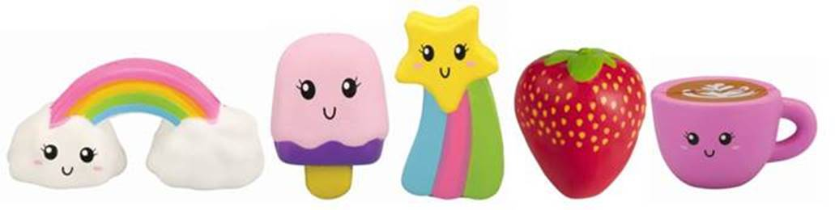

***Image for publication: The latest phenomenon in toys - ‘Squishy’ toys retail from $4 at*** [***The Warehouse***](https://www.thewarehouse.co.nz/p/squishy-food-theme-assorted/R2417012.html#q=squishy&start=1)***.*** [High res images available here.](https://www.dropbox.com/sh/7l1f1uzdotn54e6/AACcBpp0JwVWsffviJi8JWK5a?dl=0)

Move over fidget spinners, Squishies are the latest fidget toy to take the kids’ play world by storm.

The cute, squishable characters – each with their own unique persona and fruity scent, are being snapped up by kids across the globe and have flown off the shelves since landing in New Zealand this month.

Lonnica van Engelen, Buying Manager for Toys and Sporting at The Warehouse says that more than five thousand of the lovable characters were snapped up in the first week alone.

“Toys is a category dominated by the “next cool thing”, and it looks as if squishies are set to be that toy this winter.

“There are so many fun characters to choose from and kids love being able to build up a collection that they can organise, look after and share with friends. We’ve even seen customers set up shelves in their homes just to display their favourite squishies,” she says.

While fidget toys like these were originally developed to help children to maintain concentration, Van Engelen says that’s not necessarily the main appeal here, pinning their real success to the spongy-like texture that makes them just so fun to play with.

“As you squish them, there’s lots of fun in watching it slowly spring back into its original shape. People just love playing with them – young and old.”

Squishy toys start from $4 and are available in a range of characters. The full range can be viewed [here](https://www.thewarehouse.co.nz/p/squishy-food-theme-assorted/R2417012.html#q=squishy&start=1).

For more information, please contact:  
  
Sarah Leaning, PR Manager  
The Warehouse Group, [sarah.leaning@thewarehouse.co.nz](mailto:sarah.leaning@thewarehouse.co.nz)  
021 0630 208